# Reproduction

**How Do Organisms Reproduce?**

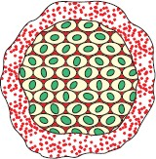

**Reproduction** is the ability of living organisms to produce living beings similar to themselves.

The two modes of reproduction, i.e. asexual reproduction and sexual reproduction can be seen in animals.

## Importance of Variation

* Sexual reproduction provides great scope for variation.
* Variation is important for the survival of a species.
* Variation helps a species to adapt to different environmental changes.

### Reproduction and its Kinds

|  |  |
| --- | --- |
| **Sexual Reproduction** | **Asexual Reproduction** |
| * It involves the formation of special   reproductive cells called gametes. | * It does not involve the formation of   gametes. |
| * Male and female gametes fuse to form   the zygote which develops into a new individual. | * New organisms are formed either by the   division of the parent body or by the differentiation of the parent body. |

**Modes of Asexual Reproduction**

Plants and animals from lower classes reproduce by asexual methods.

|  |  |  |
| --- | --- | --- |
| **Method** | **Description** | **Example** |
| Binary Fission | * Most common method in unicellular organisms. * It is division of the parent cell into two identical daughter organisms. | Amoeba, Paramecium, bacterium |
| Multiple Fission | * Parent cell divides to produce many identical new individuals. | *Plasmodium vivax*, *Leishmania* |

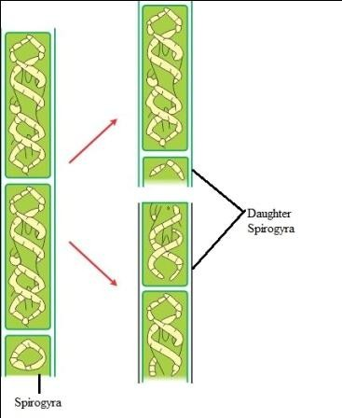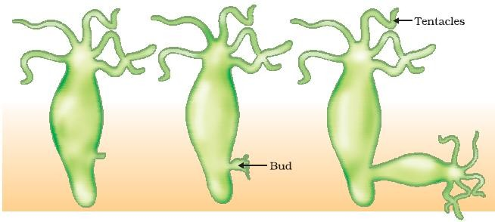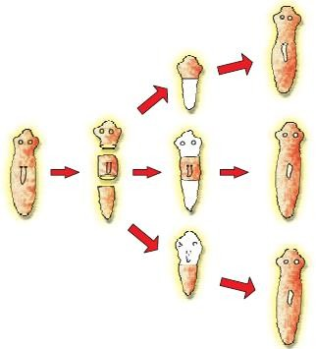

|  |  |  |
| --- | --- | --- |
| Fragmentation | * Adult organisms, on maturation, break up into smaller fragments. Each fragment develops into a new individual. | Spirogyra |
| Budding | * A small outgrowth called a bud arises on the parent body. * The bud grows by repeated cell divisions. * It then breaks off from the parent body and develops into a new individual. | Hydra, sponges, corals, yeast |
| Regeneration | * Regeneration is the ability of organisms to generate lost or damaged body parts. * Regeneration is carried out by specialised cells. * These form a mass of cells which undergo changes to form cells specialised in different functions. * If planaria is cut into small pieces, then   each piece develops into a new planaria. | Lizard, starfish, planaria, hydra |
| Spore Formation | * Spores are special structures produced in sacs called sporangia. * When spores mature, sporangia burst and spores are carried by air or water to different places. * When spores fall on a suitable ground, they germinate and give rise to new   plants. | Moss, Fern, Fungi |
| Vegetative Propagation    **Vegetative propagation in *Bryophyllum*** | * Several plants are capable of producing naturally through their roots, stems and leaves. Such type of reproduction is called vegetative propagation. | Sweet potato (by roots) *Bryophyllum* (by leaves)  Ginger (by stem) |

Different methods used to develop plants which can bears fruits and flowers by vegetative propagation are as follows:

* 1. **Stem cutting:** This involves cutting a part of the stem and planting it in the soil to allow the growth of roots and buds into shoots.

Examples: sugarcane, pear, china rose

* 1. **Grafting:** In grafting, the stem or bud of two best quality plants is combined to form a new plant. Examples: guava, apple, mango
  2. **Layering:** In this, the lower branch of a plant is bent and covered with soil. Once new roots start

developing on the branch, it is cut from the parent plant and allowed to grow as an individual plant. Examples: rose, jasmine

### Tissue Culture

* Cells from the growing tip of a plant are separated and are grown on a nutrient medium containing all nutrients and hormones necessary for plant growth.
* These cells form a mass called callus.
* The callus develops plantlets.
* These plantlets are transferred to the soil and grow as new individuals.

### Advantages of Vegetative Reproduction



New plants show the exact characteristics as those of the parent plant. This method is faster and certain.

Plants not capable of producing sexually can be produced by this method.

Examples: Seedless bananas and grapes

**Disadvantages of Vegetative Reproduction**

There is no possibility of variation.

The new plant grows in the same area as the parent plant which leads to competition for resources.

**Sexual Reproduction**

* In sexual reproduction, two gametes or germ cells, i.e. the male gamete called sperm and the female gamete called ovum, are involved.
* Both the sperm and ovum fuse together to form a zygote which develops into a new individual.

### Sexual Reproduction in Flowering Plants

A **flower** is the reproductive organ in angiosperms.



Stalk/Pedicel

* Point of attachment.

Thalamus

* It is an enlarged, flattened tip of the stalk.
* Petals and other parts arise from the thalamus.

Calyx

* Outermost whorl of the flower consisting of sepals.
* The calyx protects the inner parts of the flower in their bud stage.

Corolla

* Second whorl of the flower which is made up of petals.
* Helps flowers in attracting insects to carry out pollination.

Androcium

* Third whorl and the male organ of the flower.
* Consists of stamens.
* Each stamen is made of the filament and anther.
* Anthers store pollegrains.

Gynoecium

* Innermost whorl and the female reproductive organ.
* Consists of pistils or carpels.
* Carpel is made of stigma, style and ovary.

# Pollination

* Pollination is the transfer of pollens from the anther to the stigma of the same plant or a different plant of the same species.

## Types of Pollination



Self-pollination

The transfer of pollen grains from the anther to the stigma of the same flower.



Cross-pollination

The transfer of pollen grains from the anther of one flower to the stigma of another flower of the same species.

* Different agents help to bring about cross pollination. They are insects, wind, water, etc.

# Fertilisation

The process of fusion of the male gamete with the female gamete to form a zygote is called **fertilisation**.

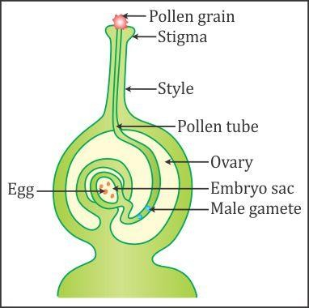

When pollen grains setttle on the stigma, they form a tube called the pollen tube.

The pollen tube grows through the style of the flower and enters the ovary.

The tip of the pollen tube dissolves to release the pollen grain into the ovary.

In the ovary, a female gamete fuses with the pollen grain to form a zygote.

# Fruit and Seed Formation

* After fertilisation, the ovary enlarges and forms a fruit.
* Scientifically, the fruit is the ripened ovary.
* Ovules become the seeds of the fruit.
* All parts other than the ovary dry up and fall off.
* Tomato, lady’s finger and brinjal are all fruits.

# Reproduction in Human Beings

## Growth and Development

* Growth and development are gradual and irreversible processes.
* Size and complexity of the body increase gradually.
* Growth in humans is divided into the following stages:

Infant

* Children between 1 month and 1 year of age are called infants.

Toddler

Adolescent

* Children between 1 to 4 years of age.
* Growth is fast.
* Children learn to balance the body.
* Children between the ages of 11 to 19 years.
* The period of transition from childhood to adulthood is called adolescence.

Adulthood

* It is from the age of 18 years onwards.
* An individual attains full growth and emotional stability.
* Career and shouldering responsibilities are priorities.

# Puberty

**Puberty** is the period during which the reproductive system matures in boys and girls.

* In girls, puberty begins at the age of 11 years.
* In boys, it begins at the age of 12–14 years.
* Puberty continues till the age of 18 years.

## Changes Which Occur At the Time of Puberty

|  |  |
| --- | --- |
| **Changes in Boys** | **Changes in Girls** |
| 1. Testes mature and start producing  sperms. | 1. Ovaries mature and start producing ovum.  The menstrual cycle begins. |
| 2. Pectoral girdle (shoulder girdle) grows. | 2. Pelvic girdle (hip girdle) becomes broad. |
| 3. Hair growth in the pubic region. | 3. Hair growth in the pubic region. |
| 4. The skin in the pubic region becomes  darker. | 4. The skin in the pubic region becomes  darker. |
| 5. Development of moustache and beard. | 5. Enlargement of breasts. |
| 6. Development of a deep voice. | 6. The voice becomes shrill. |

**Problems Related to Adolescence**

**Adolescence** is a period of physical, mental and emotional changes.

* The spurt of growth in certain body parts creates confusion in teenagers. They start worrying about it. They start feeling lonely and do not feel comfortable to share their problems with others.
* Teenagers become highly sensitive about someone’s opinion.
* They tend to become angry or upset very easily.
* They prefer the company of persons their age.
* Due to hormonal changes, they experience depression.
* They feel the urge to become independent but are unsure about themselves.
* They have many questions about sex.
* This makes it important to counsel them in the right manner.

# Male Reproductive System

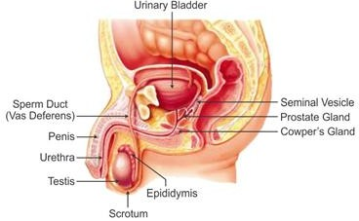

|  |  |
| --- | --- |
| **1. Testes (Testicles)** | * A pair of testes is located below the abdomen in the scrotal sac or scrotum. * The testes produce male gametes or sperms (germ cells). * To maintain the temperature 2–3°C below the body temperature, the scrotum is located outside the body cavity. |
| **2. Epididymis** | * Tubes present in the testes join to form the epididymis. * The epididymis stores sperms temporarily. |
| **3. Vas deferens (sperm duct)** | * Each epididymis continues further as the sperm duct or vas deferens. * Each vas deferens unites with a tube coming from the urinary bladder on either side. * Thus, the urethra is the common passage for sperms and urine. |
| **4. Seminal vesicles** | * The seminal vesicles produce a secretion which is responsible   for the transport of sperms. |
| **5. Prostate gland** | * It is a bilobed structure which surrounds the urethra. * It pours an alkaline secretion into the semen. |
| **6. Cowper’s gland** | * These are two small ovoid glands. * They open into the urethra. * Their secretion serves as a lubricant. |
| **7. Penis** | * The urethra passes through the penis. * It carries either urine or semen at a time. |

## Female Reproductive System

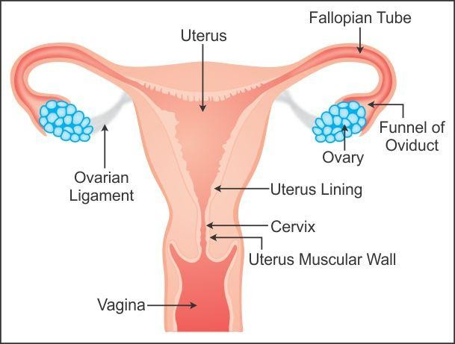

|  |  |
| --- | --- |
| **1. OVARIES** | * Two ovaries are present in the pelvic cavity, one on each side of the uterus. * Ovaries produce ova which are female gametes. * One ovum is released by one ovary every month. |
| **2. OVIDUCTS (Fallopian tube)** | * Two oviducts or fallopian tubes are present, each close to one ovary of its side. * When the egg is released by the ovary, it passes down to the uterus   through the oviduct. |
| **3. UTERUS (Womb)** | * The uterus is a hollow pear-shaped, muscular organ. * The inner lining of the uterus called endothelium protects and nourishes the developing embryo. |
| **4. VAGINA (Birth canal)** | * The uterus opens into the vagina. * The vagina is a muscular, narrow tube. |
| **5. VULVA** | * The vagina and urethra both open into the vulva. |

**Fertilisation**

The process of fusion of the male gamete with the female gamete is called **fertilisation.**

## If Fertilisation Takes Place

Fertilisation occurs in the oviduct.



At the time of intercourse, semen is deposited into the female's vagina.

Sperms swim through the uterus and reach the oviduct.

A single sperm fuses with the ovum and forms the zygote. This completes the process of fertilisation.

## Implantation

* As soon as the zygote is formed, it starts developing.
* By the time it reaches the uterus, it is a mass of cells known as an embryo.
* It remains attached to the wall of the uterus throughout its development.
* The period of development of the embryo inside the uterus is called the **gestation period**.
* In humans, the gestation period is of 9 months, i.e. about 280 days.
* The embryo after completing three months of development is called the foetus.
* The placenta is a special tissue which provides food and oxygen to the foetus.

## If There Is No Fertilisation



If the ovum is not fertilised, then it lives for one day. The lining of the uterus breaks down and disintegrates.

The ovum, lining of the uterus and some blood are discharged out of the body.

This is called menstruation.

The menstrual discharge lasts for four days.

After menstruation, the ovum is released, and the uterus again prepares itself for the receival of the fertilised egg cell.

If there is no fertilisation, then menstruation is repeated.

**Reproductive Health**

**Sexually Transmitted Diseases**

|  |  |
| --- | --- |
| 1. **Gonorrhoea** 2. **Syphilis** | * Caused by bacteria. * Bacteria spread through sexual contact. * Burning sensation during urination. * Urethral discharge containing pus. * Sores in genitals. * Both diseases are curable. |
| **3. AIDS (Acquired Immuno Deficiency Syndrome)** | * AIDS is caused by the infection of HIV (Human Immunodeficiency Virus). * This virus attacks the immune system itself. * HIV penetrates the T-lymphocytes. * Reduction in the number of T-cells reduces the immunity of a person. * HIV is transmitted by   + Sexual intercourse   + Sharing contaminated needles   + Blood transfusion of contaminated blood   + From the infected mother to the unborn foetus * To create awareness about the severity of AIDS and protection from HIV, the **1st of December** is **World AIDS Day**. |

### Different methods are available in order to prevent pregnancy:

#### Hormonal Method:

Various hormonal preparations come in the form of tablets or pills, commonly called contraceptive pills.

#### Barrier Methods:

Condoms, diaphragms and spermicidals are used.

Condoms are used by males while diaphragms and spermicidals are used by females.

#### Intra-uterine Devices (IUDs):

IUDs such as Lippe’s loop and copper – T are fitted in the uterus. They prevent fertilisation.

#### Surgical Methods:

In females, the fallopian tubes are ligated. This is called tubectomy. In males, the vas deferntia are ligated. This is called vasectomy.

#### Induced Abortion:

It is also known as Medical Termination of Pregnancy (MTP).

If a woman becomes pregnant and the couple is not willing to have a baby, then the option of induced abortion is chosen.